COAL LAB # 3
Exercise # 1
- Largest 8-bit value will be obtained when all the bits are 1.(11111111)₂
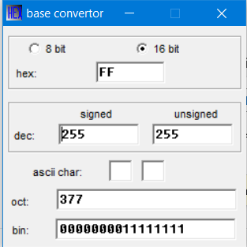

- Smallest 8-bit value is (00000000)₂. However, we want smallest negative value so the MSB will be changed to 1, making it (10000000)_{2.}
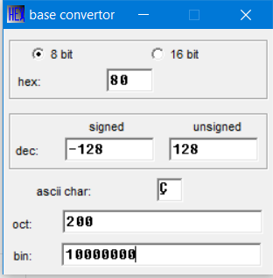

- Largest 16-bit value is (1111111111111111)₂.
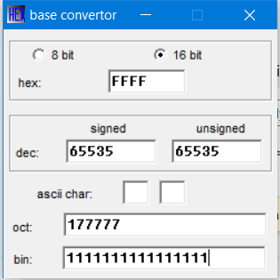

- Smallest 16-bit value is 0000000000000000. But we will change MSB to 1 to make it negative.
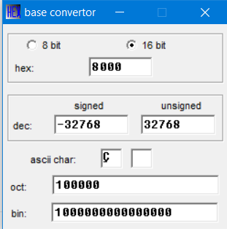

Exercise # 2:
- 10110011 (Binary to Hexadecimal)
- To convert binary to hexadecimal, we first separate the binary numbers into groups of four.
- Then, convert each four-bit binary number into Hexadecimal digit.
- After that, we combine all the obtained Hexadecimal digits into one number which will be the final result.
Manual Calculation:
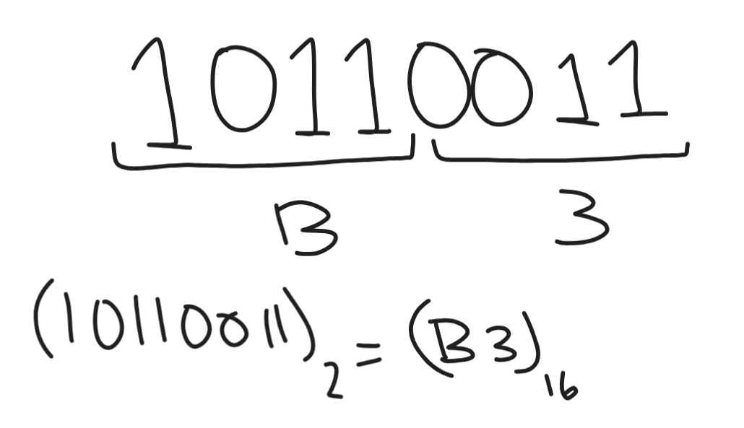
Base Convertor:
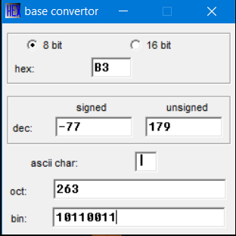

- 455 (Decimal to Binary)
- To convert the Decimal to Binary, first find the largest power of 2 that fits in the decimal number.
- Subtract that power from the number.
- Repeat with the remaining value until you reach 0.
- Write 1s for the used powers and 0s for the missing ones.
Manual Calculation:
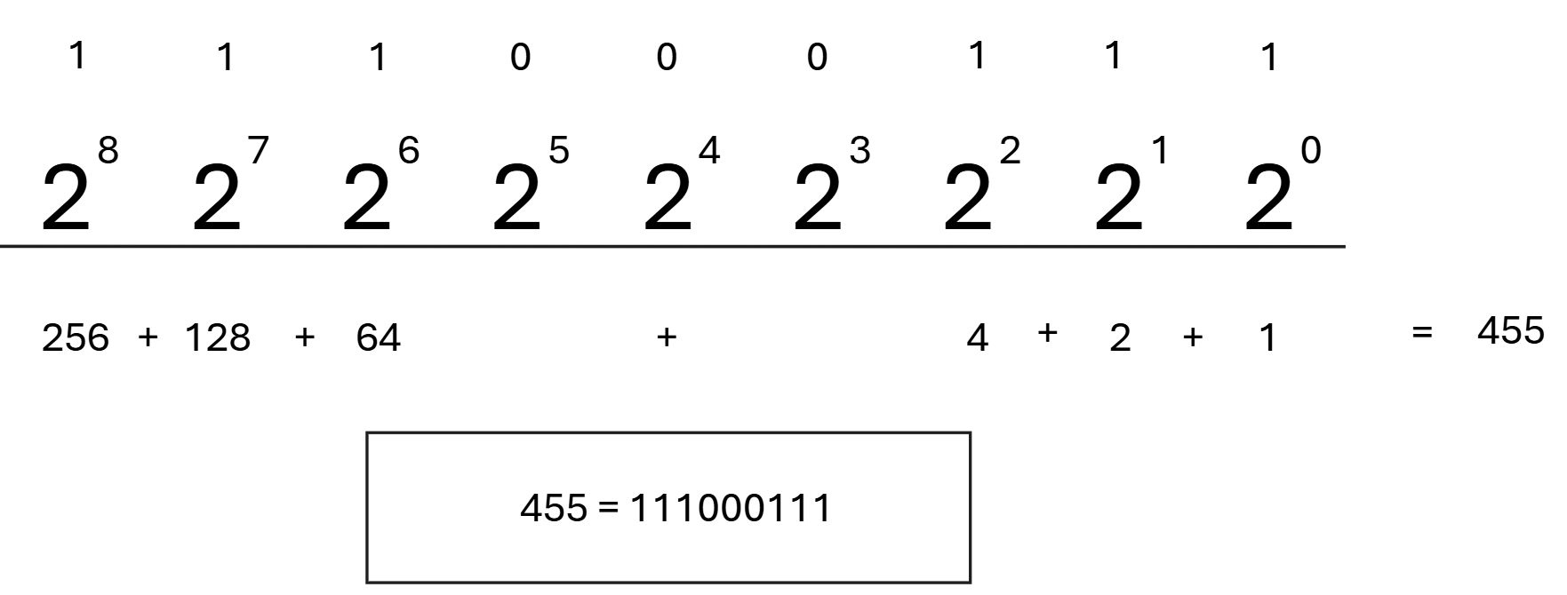

Base Calculator:
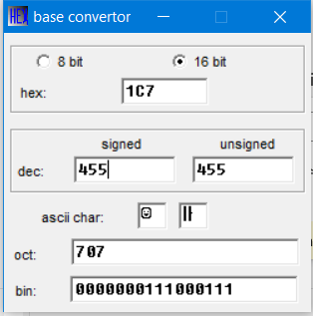

- 2AF (Hexadecimal to Binary)
- For converting Hexadecimal to Binary, each hexadecimal digit id converted to a four-bit binary number.
- Then all these four-bit binary numbers are combined to get the whole binary number.
Manual Calculation:
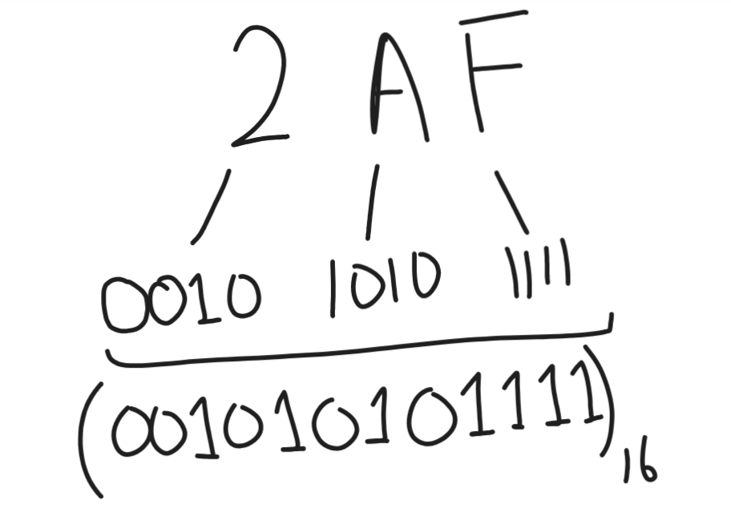
Base Calculator:
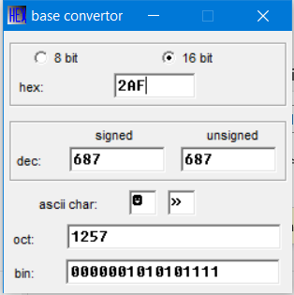

- 0A1 (Hexadecimal to Binary)
Manual Calculation:
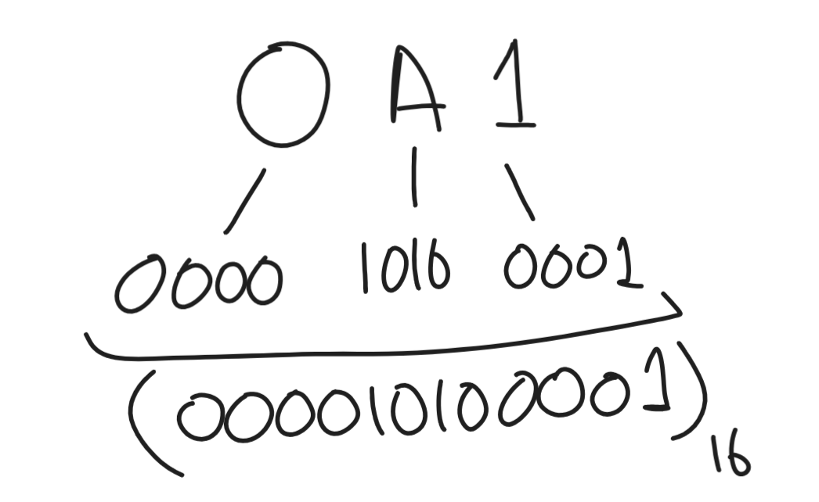

Base Calculator:
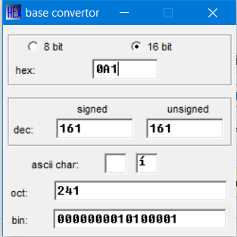

Exercise # 3
- -1 = 11111111
- -17 = 11101111
- -19 = 11101101
- -62 = 11000010
- 127 = 01111111
- -128 = 10000000

Exercise # 4
- 01011100 = 92
- 11011100 = -36
- 10001111 = -113
- 01111110 = 126
- 10010001 = -111
- 10000000 = -128

Exercise # 5
- 7FB9 = 32697 (positive)
- 8123 = -32477 (negative)
- D000 = -12288 (negative)
- 6FFF = 28671 (positive)
Exercise # 6
Four software tools commonly used for assembly language programming are:
- Assembler (MASM (Microsoft Macro Assembler))
- Debugger (OllyDbg)
- Emulators (EMU8086, QEMU)
- Integrated Development Environment (MARS)

